Threat Control
Application
Software

INDEX

- Introduction
- Software Requirement Analysis
- Module and Design Organization
- Output Screens
- Conclusion
- References

1. INTRODUCTION
To develop any software, the first thing needed is the objective of the project and the scope of the project. An introduction about the project objective and the project scope gives an idea about the project.
1.1 Problem Definition
To find out “threat value” of a particular person using their mobile through this software.
1.2 Objective of Project
The main objective of the project is to create an interface between the host system and the individual mobile phone. A Graphical User Interface (GUI) is created using Java on windows platform to track the movement of the person.

2. SOFTWARE REQUIREMENT ANALYSIS

2.1 Software Requirement Specifications
The threats location must be trapped using the software .The recorded database will be stored in the hard disk. To view the movement of the person in the software we need to install few more software’s like JxBrowser, Jfreecharts.
2.1.1 User Interface Requirements
In the monitor page, the user is required to click on the mobile number of the person for who he/she want to know about.
2.1.2 Software Requirements
- JAVA
- MySQL Database
- JxBrowser
- JxBrowser –lib- lisence.JAR
- JfreeCharts
- Notepad++
- Mysql-connector-java-5.1.39-bin.JAR
- NetBeans IDE 8.2

2.1.3 Hardware Requirements
- Computer (PC)
2.1.4 Communication Interfaces
- Mobile Phone
2.2 Content Diagram of Project
Threat
Control
Application

Receiver
(PC)
Mobile Phone

3. Module Design and Organization
3.1 Communication Module :
This module deals with the mobile phone of the individual. This acts as an interface between the host system and the PC. The PC is set with all the required software’s to run our Java Application
The software is designed for connection directly to a database provided by mobile service provider to a PC. There are different parameters on which we can rely upon.
3.2 Database Module (MySQL)
The database module deals with storing the entire database of the recorded information like details of the person, his previous activities, his/her mobile information along with the previous threat values. Later on, we have linked MySQL database with our application.

4. OUTPUT SCREENS

4.1 Introduction
A simple GUI is created using JAVA program in windows platform, which tracks the movement of the person with the computer. The GUI consists of various buttons, Jframes, slider control, etc., each having a particular function as shown in the figure 3. Our main objective is to control the threats created by individual groups like Alqaida, etc,. using Java. For that each button in the GUI are interfaced with the information of Receiver which tracks the operation of the particular person. The main advantage of this is we can track all the information using the mobile information like different locations he/she is moving around. There are various analysis available in which, a particular person’s phone number can be easily selected by a mouse click on it. On selection of particular mobile number it gets highlighted as shown in the figures.

MAIN GUI
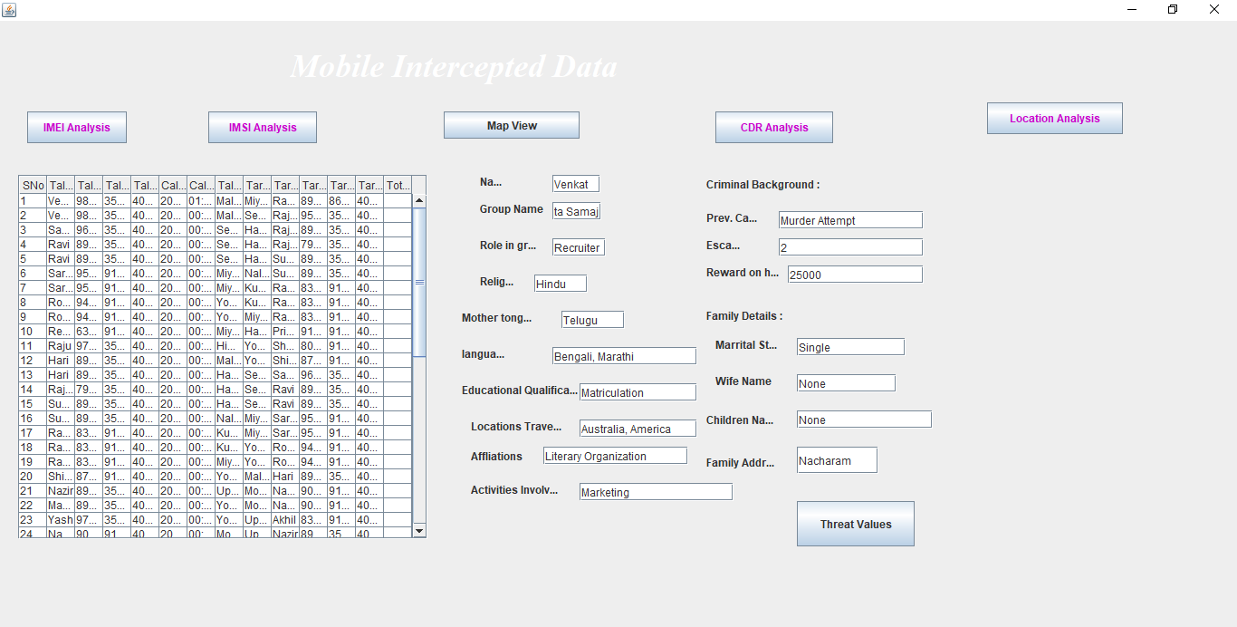

Figure 1: Initial window view without selection of any option

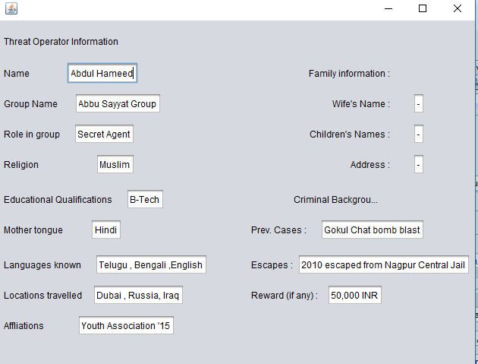

Figure 2: Highlighted options after selection of a particular mobile number.

IMEI Analysis:
An IMEI Analysis is performed when the IMEI Analysis button is clicked. This analysis includes calculating the threat value using “IMEI Number” as a parameter by finding the number of phone nos. assosciated with a single IMEI number , and then the screen will look like the figure 3.

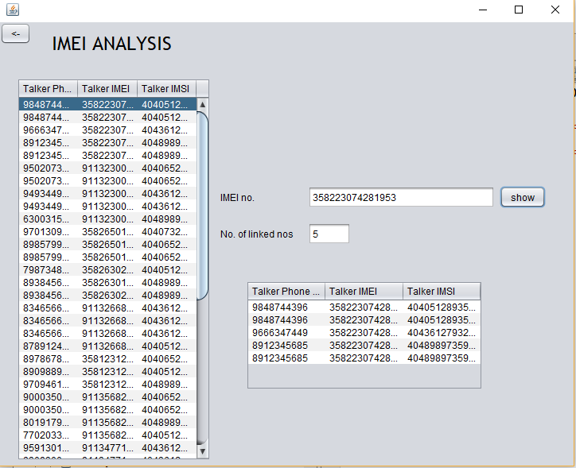

Figure 3: IMEI Analysis

IMSI Analysis:
An IMSI Analysis is performed when the IMSI Analysis button is clicked. This analysis includes finding out the operator information using “IMSI Number” and then the screen will look like.
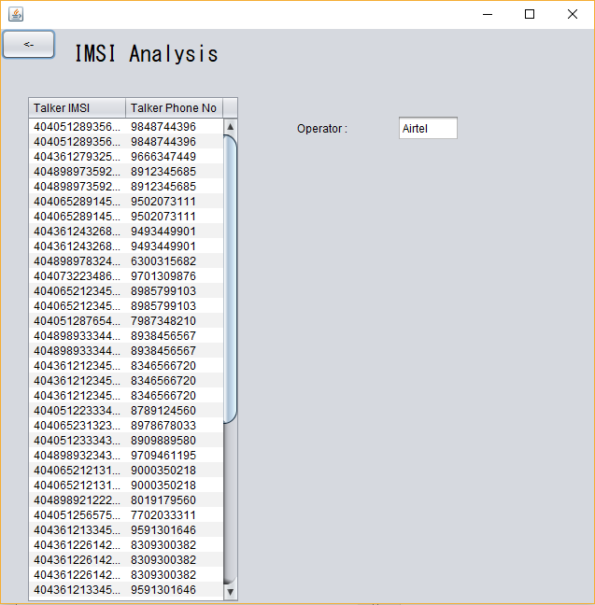

Figure 4: IMSI Analysis

Map View:
When the host clicks on this button, this gives the different locations around the country involving different cell towers provided by different cell providers like Airtel, Idea, Bsnl, Jio which are represented by different color markers on Google map which includes normal view and satellite view as well . We can zoom in or zoom out as well. The screen is shown like this
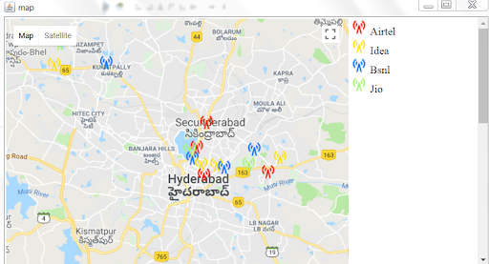
Normal View of Google Map showing different Cell towers
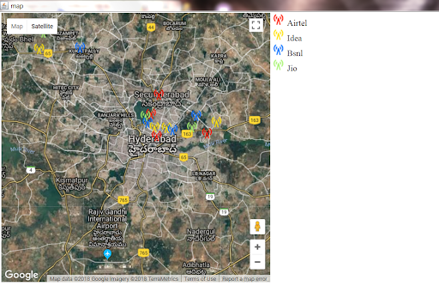
Figure 4: Satellite View of the Google Map showing Different Cell towers

CDR Analysis:
This Analysis is useful for providing threat value using “Phone Number” as its parameter. Here we are able to see the to who a particular person is speaking to in the form of Jtree embedded in Jframe. All the database comes from Jtable connected to MySQL .
When we click on this button on Main GUI ,the screen looks like this as shown in Figure5.

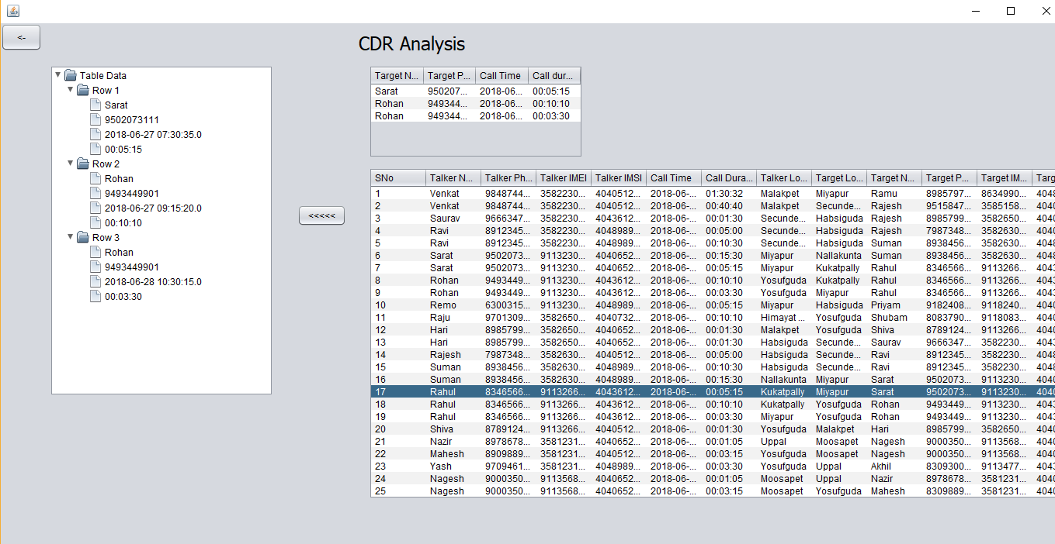
Figure5:CDR Analysis View

Location Analysis:
This includes the analysis using “Location” as its main attribute. When we click on Location analysis button in Main GUI, the screen looks like this as shown in figure6 , a histogram which displays the information of different users in a particular locality.
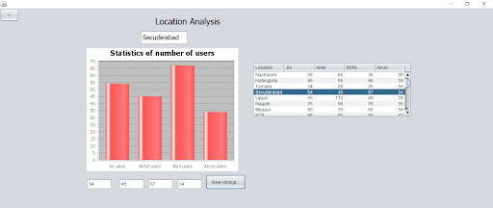
Figure 6 : Location Analysis
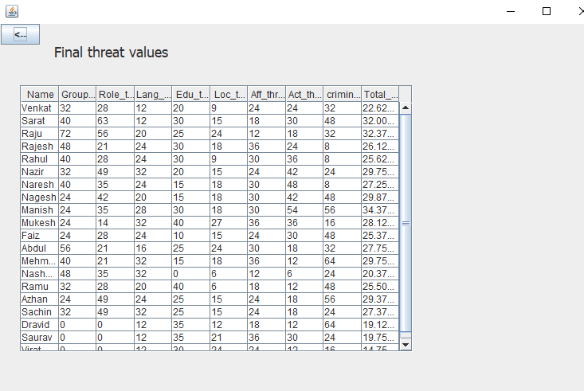
Figure 7 : Final Threat Output.

5. CONCLUSION

The person is successfully interfaced and is controlled using the host computer. The GUI is created using JAVA on windows platform. All modes available in the person are analyzed and are controlled with the software created without any errors using “threat value”. Since every fields of the screens are explained with different operations present in that field, the user can know whether the movement of the person is a enemy threat or not.

6. REFERENCES

- Google Developer Console.
- JAVA tutorials
- Wikipedia

